RESUME

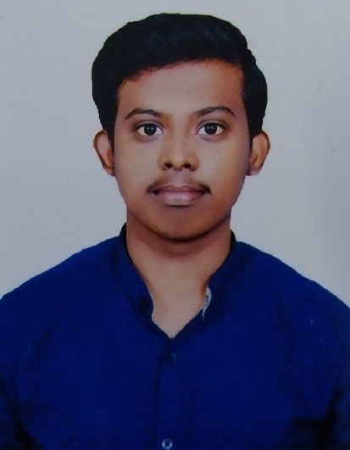

M.ESHWAR SAI

Phone: 9346628441

E-mail:eshwarsai2101@gmail.com

**CAREER OBJECTIVE:**

To obtain a growth-oriented position as a Software Engineer in a leading multi-national organization where I can use my qualifications and skills to prove my abilities.

EDUCATIONAL QUALIFICATIONS:

|  |  |  |  |  |  |
| --- | --- | --- | --- | --- | --- |
| **S.No.** | **Examination passed** | **Name of Institute / University** | **Discipline / Subject** | **Month & Year of Passing** | **Percentage of Marks** |
| 1. | B.Tech  (Pursuing) | ACE  Engineering College,  Hyderabad | Electronics & Communication Engg. | March, 2025 | 7.33  (Till Date) |
| 2. | Intermediate | Sri Chaitanya  Junior kalasala, Hyderabad | Maths,  Physics, Chemistry. | March, 2021 | 7.92 |
| 3. | S.S.C | Krishnaveni Talent School, Hyderabad. | Maths, Science, Social Studies | March, 2019 | 8.0 |

TECHNICAL PROFILE:

1. Operating Systems : Windows &Android
2. Languages **:**  Basics of python & C

**PROJECT REPORT:**

1. Title : Blinking Lights by using 555 timer IC
2. Duration : August to September (2023)
3. Purpose : To show Flickering of lights.
4. Material Used : Breadboard,555 Timer IC, Led, Connecting wires, etc.
5. Team Size **:** Three (3)

**ACHIEVEMENTS:**

* Participated in the Workshop of hands on training on Arduino (hardware).
* Certified from general electronics
* Successfully completed a Salesforce virtual internship and obtained certification from both Smartbridge and AICTE.

**STRENGTHS:**

* Positive attitude
* Self motivated
* Team management

**WEAKNESSES:**

* Difficulty in saying NO
* Going deep into given work

**HOBBIES:**

* Reading books
* Playing Cricket
* Listening to music

**PERSONAL PROFILE:**

Date of Birth : 21-01-2003

Languages known : Telugu, Hindi & English

Father’s Name : Mr. M.Haribabu

Mother’s Name : Mrs. M.Swapna

Address **:** H.no – 13-1-112, seetharambagh,mehdipatnam, Hyderabad

**DECLARATION:**

It is hereby acknowledged that the information furnished above is true to my knowledge

**Place :** Hyderabad

**Date :**8/02/2024 **Signature**

* * *